Information   
about the cost of paid medical services   
in City Emergency Station Healthcare Institution.  
Zaharova street 52, building 1, Minsk, 220088.

bank account BY94BLBB36040100139896001001 at CBM № 535 of Belinvestbank JSC, Minsk,  
code BLBBBY2X, UNP (Tax Payer Number) 100139896  
(Services appear on the contract basis)

enactment from 2023.03.01

|  |  |  |  |  |  |  |  |  |  |
| --- | --- | --- | --- | --- | --- | --- | --- | --- | --- |
| No. | Name | Unit | Rate including VAT, bel.rub | | | | Value  of medical agents, items of hospital assignment, etc. materials, bel.rub | Third parties services, bel.rub | Cost including VAT, bel.rub |
| according to pricelist | with allowance for the provision of night time service | with allowance for the provision of holiday service | with allowance for the provision of holiday night time service |
| 1. | Medical examination for permit to work | service | 2,76 |  |  |  | 0,03 | 0 | 2,76 |
| 2. | Transportation of a citizen under medical worker’s escort at citizen’s will without medical indications (within Minsk) | service | 33,82 |  |  |  | 0 | 35,03 | 68,85 |
| 3. | Medical support of mass and other events by the specialized ambulance team | 1  hour | 68,10 | 88,54 | 102,16 | 122,58 | The cost of medicines, medical devices, other materials is calculated based on their actual consumption in the provision of services and purchase prices.  The cost of services of third-party organizations (transport services) are calculated at the rates of KUP "MinskSanavtotrans" for the time it takes to provide the service and the mileage of a special ambulance for this period. Service delivery time is calculated on the basis of: less than 15 minutes. not taken into account, 15-45 is rounded up to 30 min., over 45 min. rounded up to 1 hour. Service time is calculated from the moment the brigade leaves the station (substation) until it arrives at the station (substation), or until the visit is received. | |  |
| 4 | Medical support of mass and other events by the feldsher ambulance team | 1 hour | 42,26 | 54,95 | 63,40 | 76,08 |  |
| 5. | Specialized ambulance team on-site visit (resuscitation team, intensive care team) (for foreign citizens) | one visit | 645,00 |  |  |  |  |
| 6. | Specialized ambulance team on-site visit (pediatric team) (for foreign citizens) | one visit | 481,00 |  |  |  |  |
| 7. | Specialized ambulance team on-site visit (psychiatric team) (for foreign citizens) | one visit | 538,00 |  |  |  |  |
| 8. | Feldsher ambulance team on-site visit (for foreign citizens) | one visit | 412,00 |  |  |  |  |

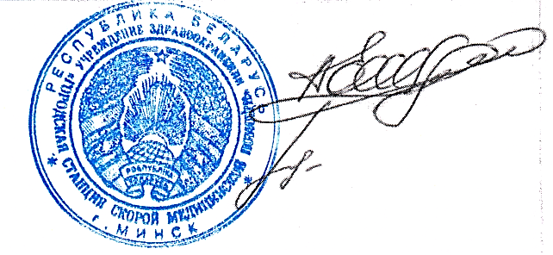

Head Physician A.E. Zhinko

Head of the Planning   
and Economy Department A.G. Labetsik